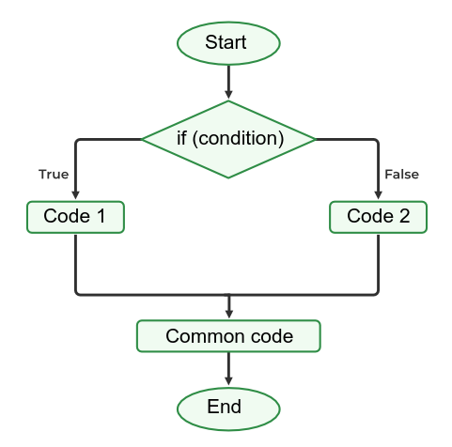
English Vocabulary – Binary-Specific Words

“Binary-specific” words (or word pairs) are terms which apply to exactly two items. For example:

1. Both… and
The word ‘both’ refers to two items together.
- Both cars and trucks pollute our cities.
- I like both cats and dogs.
- Both John and Mary attended the service.

2. Each other
This expression refers to reciprocal relationships between two parties.
- They looked at each other.
- John and Peter trust each other.

3. Either… or
These words define a binary choice.
- Either the manager or the assistant will call you.
- You can have either a hamburger or a hot-dog.

4. Neither… nor
These words define a binary negative choice.
- Neither the teacher nor the student could solve the problem.
- I want neither chocolate nor strawberry ice-cream. I want vanilla!
- A: We should choose Option B or Option F.
B: In my opinion, neither option is suitable. (two items are implicitly implied)

5. Between... and
This is a preposition to define a position (physical or otherwise) relative to two items/ideas.
- I can’t choose between options A and B.
- The cat is sleeping between the armchairs. (there are only 2 armchairs)
- I’m stuck between a rock and a hard place.
- I’m between jobs at the moment.

6. From… to
This pair of words defines a start and an end point.
- I work from Monday to Friday, from 8am to 6pm.
- We drove from Chicago to New York.

7. If… then… else
This programming instruction defines a two-path condition.
- if total=0 then print “Empty” else print “Not empty”
- if true then code1 else code2

8. Instead of / Rather than
These expressions define an alternative (second) choice.
- I think I will stay at home instead of going out tonight.
- Let’s go to the mountains this year rather than the beach.

9. Versus (vs.)
This word defines a contest or an argument between two entities/ideas.
- I’m going to watch the match of Brazil vs. Argentina.
- I need to analyse your idea versus that of my son.

10. Per
The word ‘per’ implies a ratio of two numbers.
- Miles per hour
- Cost per person
- Trips per year

Some words form natural pairs:

- true / false
- boy / girl
- man / woman
- black / white
- up / down
- in / out
- left / right

